**Lab01: Foundation statements of SQL**

**Exercises**

Using StudentInformation database, formulate the following queries:

1. Get StdID, StdName, StdDOB, StdPhone and ProgID from Std table.

Query:

select StdId,StdName,StdDOB,StdPhone,progId from Std

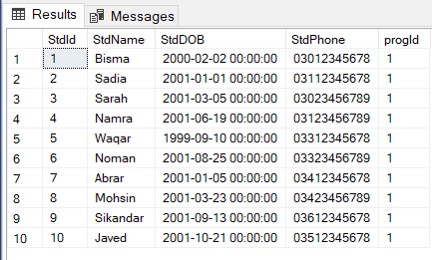

1. Select all permanent teachers from teacher table.

Query:

select * from Teacher where Status = 'Permanent'

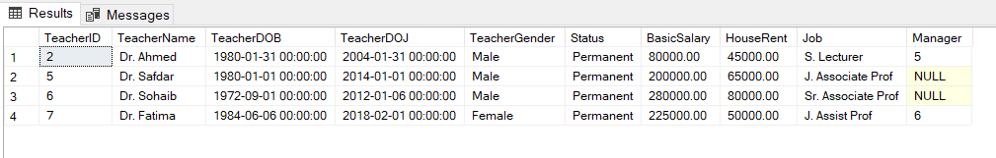

1. Display all the Program IDs that have students enrolled without repetition from Std Table.

Query:

select distinct progId from Std

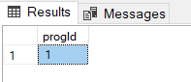

1. Display data of all students who belong to ProgramID = 1

Query:

select * from Std where progId = '1'

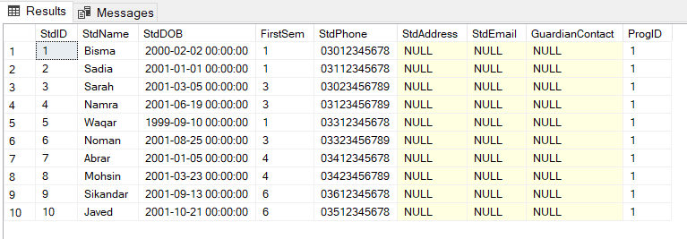

1. Display names of students who belong to ProgramID=1.

Query:

select StdName from Std where progId = '1'

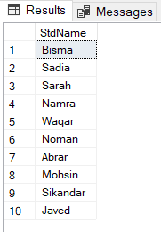

1. Display all faculty names and their Manager number from Teacher table.

Query:

select TeacherName,Manager from teacher

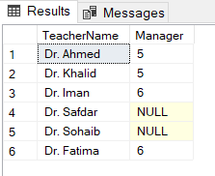

1. Display all lab based courses, which are being taught in either Computer Science program or IT program.

Query:

select Coursename from Course where CreditHrsLab='1'

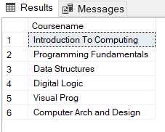

1. Display name and salary of teachers where salaries lies in the range of 100 K to 200 K.

Query:

select teachername,basicSalary from teacher where basicSalary between '100000' and '200000'

